
Course Code: CS/C/7153- WEB TECHNOLOGY
COMPUTER AND MATHEMATICS (CSMT2025)
KEKI BORA WEBSITE ASSIGNMENT TWO
Group 1 Work
Members:
- Waluchwati Wafula Denis- 2025CS162306
- Kiplangat Kirui- 2025HA162537
- Cheronoh Koech Faith- 2025CS162262
- Chepkwony Kenneth Kibet- 2025CS162862
- Denis Kipkurui- 2025CS162265
- Kipkirui Phineaus- 2025CS162651

QUESTION 1
Well labelled diagram for the Home Page

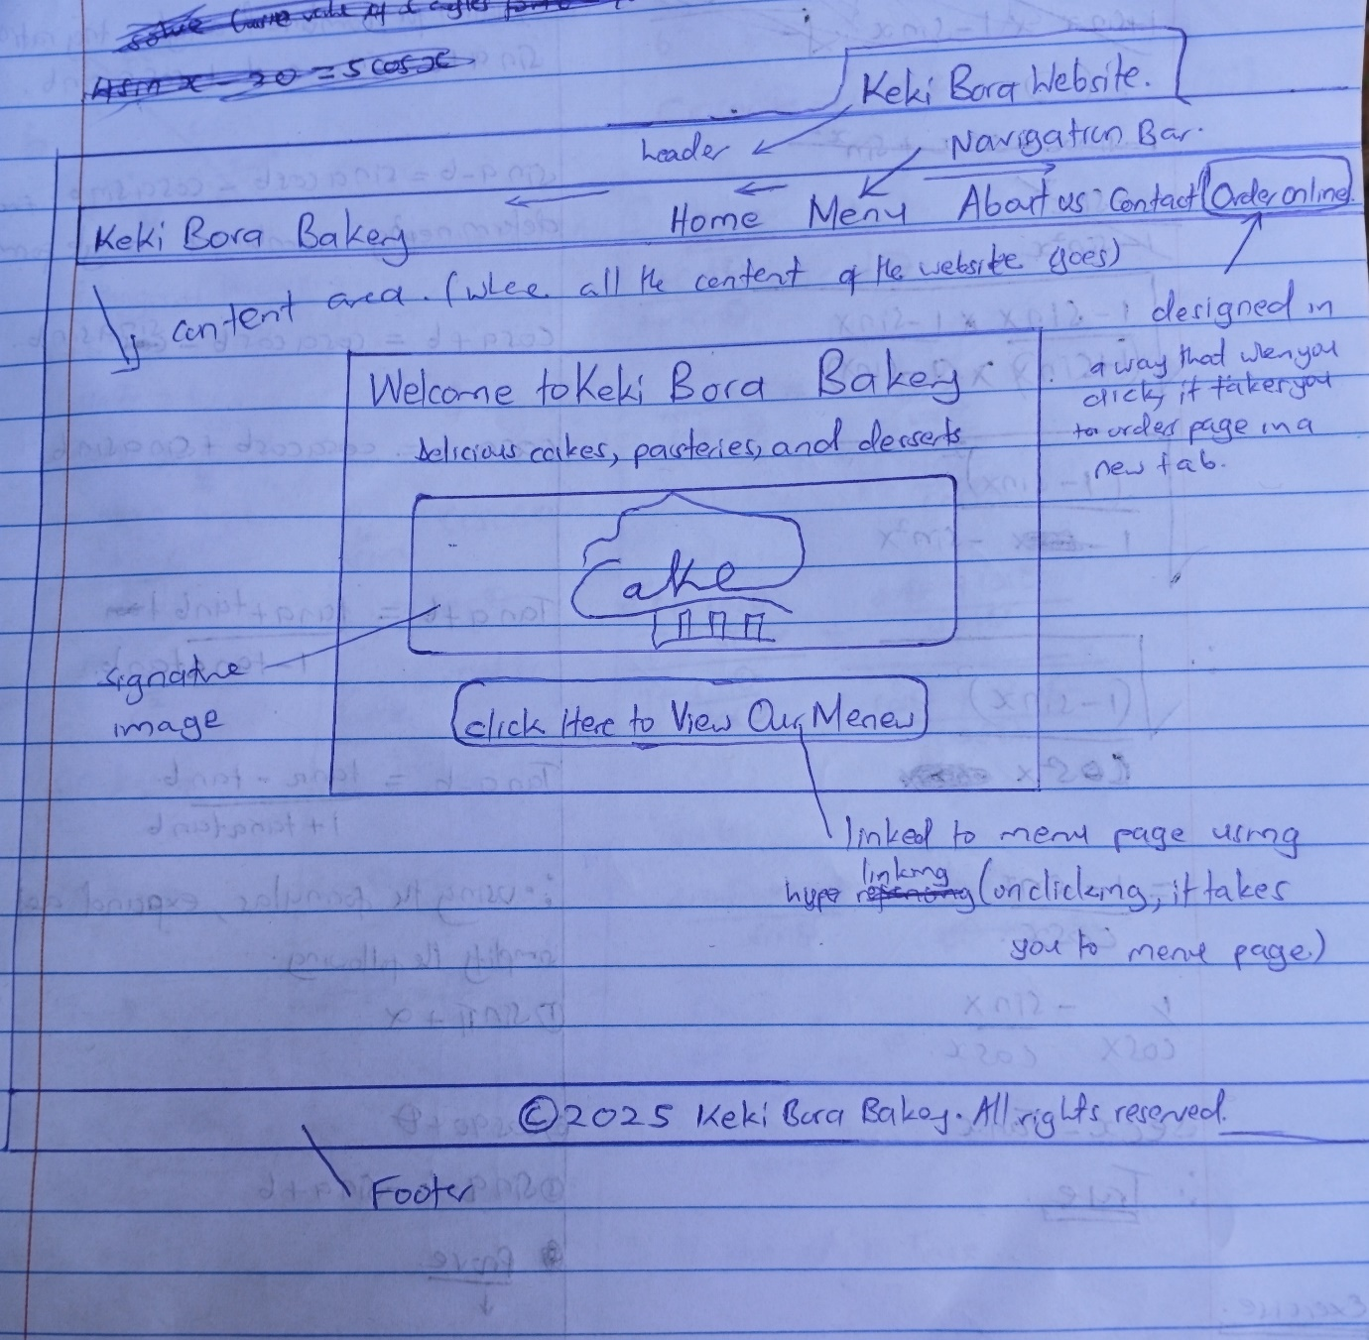
QUESTION 2
Code for basic Home elements
<!DOCTYPE html>
<html lang="en">
<head>
<meta charset="UTF-8">
<meta name="viewport" content="width=device-width, initial-scale=1.0">
<title>Keki Bora Bakery</title>
</head>
<body>
<nav>
</nav>
</header>
</body>
</html>
QUESTION 3
Keki Bora Navigation Bar
<nav>
<div class="logo">Keki Bora Bakery</div>
<ul>
<li><a href="index.html">Home</a></li>
<li><a href="menu.html">Menu</a></li>
<li><a href="about.html">About Us</a></li>
<li><a href="contact.html">Contact</a></li>
<li><a href="order.html" class="order-btn">Order Online</a></li>
</ul>
</nav>
QUESTION 4
Code for signature cake Image
<div class="menu-item">
<a href=“menu.html”>
<img src=“Signature-cake.jpg” alt=“Signature-cake”>
</a>
</div>
QUESTION 5
Code for List of Menu Items
<section class="menu">
<h2>Our Menu</h2>

<div class="menu-category">
<h3>Cakes</h3>
<div class="menu-item">
<img src="chocolate-cake.jpg" alt="Chocolate Cake">
<div>
<h4>Chocolate Cake</h4>
<p>Rich and moist chocolate cake topped with creamy frosting.</p>
<span>Ksh.1500</span>
</div>
</div>
<div class="menu-item">
<img src="vanilla-cake.jpg" alt="Vanilla Cake">
<div>
<h4>Vanilla Cake</h4>
<p>Classic vanilla cake with a fluffy texture and sweet icing.</p>
<span>Ksh.1250</span>
</div>
</div>
</div>
<div class="menu-category">
<h3>Cupcakes</h3>
<div class="menu-item">
<img src="Vegan-red-velvet-cupcake.jpg" alt="Red Velvet Cupcake">
<div>
<h4>Red Velvet Cupcake</h4>
<p>Soft red velvet cupcake topped with cream cheese frosting.</p>
<span>Ksh.20</span>
</div>
</div>
<div class="menu-item">
<img src="chocolate-cupcake.jpg" alt="Chocolate Cupcake">
<div>
<h4>Chocolate Cupcake</h4>
<p>Decadent chocolate cupcake with rich chocolate ganache.</p>
<span>Ksh.20</span>
<div class="menu-category">
<h3>Specialty Desserts</h3>
<div class="menu-item">
<img src="cheesecake.jpg" alt="Cheesecake">
<div>
<h4>Cheesecake</h4>
<p>Creamy and smooth cheesecake with a buttery crust.</p>
<span>Ksh.250</span>
</div>
</div>
</div>

QUESTION 6
Code for Contact form
<form id="contact-form">
<label for="name">Your Name:</label>
<input type="text" id="name" name="name" required>

<label for="email">Your Email:</label>
<input type="email" id="email" name="email" required>

<label for="message">Your Message:</label>
<textarea id="message" name="message" rows="4" required></textarea>

<button type="submit">Send Message</button>
</form>

QUESTION 7
Code for the Link
<a href="order.html" class="order-btn" target="_blank">Order Online</a>
QUESTION 8
Confirm with our website that we have sir. Everything is working as per the instructions

